Unit 15.B. Website Devlopment

shety003

2019

Contents

B1- Design a website to meet client requirements 4

Website design 4

Problem definition statements requirements 4

Intended audience 4

Full summary of the problem to be solved 4

Constraints 5

Technical and design constraints 5

Technical constraints 5

IT staff 5

IT equipment 5

Experience 5

Design constraints 5

Flexibility 5

Time 5

Benefits 5

Nature of interactivity 5

Purpose requirements 6

On paper designs 7

Realistic representation 7

Mood board/SEO 8

P2/M2 Alternative Design ideas and prototyping 9

Wireframe Design 1 9

Wireframe Design 2 11

Wireframe Design 3 12

Site map 14

Obtaining and using feedback from others 14

P3 Reviews 15

Client side design 16

Flowchart for video client side design 16

Psudocode for the flowchart above 16

Flowchart for download client side design 17

Psudocode for the flowchart above 17

Flowchart for navigation bar 17

Psudocode For navigation bar 18

Ready-made and/or original assets 18

Ready-made assets 18

Original assets 18

Testing plan 18

Legal and ethical considerations 21

Copyright, designs and patents act (1988) 21

Data protection act (1998) 21

B2- Common tools and techniques used to produce websites 22

HTML 22

HTML5 22

Tables 22

Forms 22

Text field 22

Text area 22

Submit button 22

Radio buttons 23

Check boxes 23

Navigation 23

Menus 23

Hyperlinks 23

Anchors 24

Interactive components 24

Hot spots 24

Pop-ups 24

Buttons 24

Rollover images 24

Colour schemes, styles and templates 25

CSS (Cascading style sheets) 25

The World Wide Web consortium 25

Accessibility features 26

Alt tags 26

Zoom features 26

Text-to-speech 26

Platform compatibility 26

Embedding and compression of assists into suitable file types 26

Image files 26

Digital sound files 26

Digital video and animation files 27

Exporting digital assets 27

B.D2 Evaluate the design and optimised website against client requirements 27

Website Optimisation 28

# B1- Design a website to meet client requirements

I will be using the principles of web design into practice by planning what my website will be based on the client’s requirement.

# Website design

There are many steps in designing a website, which if skipped would cause a lot of problems when going live, if it does not then it won’t attract as many people as it would if there was a plan with the principles.

## Problem definition statements requirements

The client’s (Green Foundation) requirements are:

* Charity profile
* Donate online
* Subscribe to our newsletter
* Subscribe to our blog RSS feed
* Follow us on social media channels like twitter and Facebook
* Purchase our merchandise
* Contribute blog comments
* Download resources on “going green” This will tie in with our major website objectives:
* Create awareness about our organization.
* Generate donations and merchandise sales
* Build an online community
* Build a repository for resources and materials on “going green”
* Advertise uniqueness of organization to partners, volunteers and the media

## Intended audience

The audience for my website will be those who have spare money that they can offer for charity, this is mostly elders and adults aged between 20-60, this is because I do not expect children to have disposable money that they can donate to a non-profit-organisation like this. It is also aimed towards organisations who are harming/helping the environment, it can be a way for us to promote the safety of nature.

## Full summary of the problem to be solved

The Green Foundation needs a website that allows people to access their information and services, this includes having a charity profile which has information about the organisation and its intent. It also must have a donation function that can be accessed through the website. It also must let the visitor subscribe to the newsletter and the blog RSS feed. Social media also has to be on the website, for example twitter and Facebook. Twitter will have a feed on the website so that people can see what type of interactions the organisation has with others. There will be a merchandise page where people can purchase items that get delivered to them, the money might go towards the cause or towards the organisation themselves. Comments on the blog will also be allowed so people can build a community which are fighting towards the cause of the organisation. There will be a downloadable document called “going green” which will have information about the organisation and the sales and donations.

## Constraints

When creating the website the first constraint I see is the recourses, the client has not provided me with any of the resources to use, for example the “going green” document is not provided, the information about the organisation is also not provided, and it is only a summary of what the organisation will do and what they hope to achieve by getting the website up and running.

## Technical and design constraints

There are two type of constraints when designing a website, these are technical, and design constrains. I will be outlining them here in this section of the report.

### Technical constraints

IT staff- The skills needed might be absent in a team or a person meaning that staff would need to be hired or trained to complete a certain part of the design, this can be costly.

IT equipment- The creation/design of the website might require specialised hardware or software that my need to be bought in or installed before the website design and development can proceed. An example of this that has occurred with this project is the software Dreamweaver, at the work place it’s supposed to be installed but it’s not. So, it has set back the development stage.

Experience- As I am a junior web developer my experience in making websites is not that advanced, so therefore not having that much experience might cost me as I might not be able to perform certain parts of the development stage.

### Design constraints

Financial- The client’s requirements for their website might not be feasible within their budget. If the client wants features that would cost more than the budget, that information has to be shown to the client to clearly outline how much money it’s going to cost.

Flexibility – When designing the website there needs to be a clear note that it is integrated into mobile devices. Otherwise it’s going to hinder the growth of the website.

Time- Not having enough time to produce the design, makes it more difficult in making the website on time if there is a deadline.

## Benefits

The benefit that the Green Foundation would have for having a website would be that they would use less money on buying posters and hiring people to stand outside getting donations from people just passing by. Also the website, if paid for and has the right services is up and running for days on end without shutting down or having a break, this is more effective than having people stand out on the street as they have to get paid and have breaks. There is also a wider audience on the internet then there is in real life and all it takes is some SEO to gather them.

## Nature of interactivity

For this website I have to keep in mind what type of website it’s going to be, is it going to be static or interactive, and if its interactive how much interactivity will I put in because if I put too much it might overwhelm the visitor, and if there is not as much as they would like they might lose interest in the website.

## Purpose requirements

In this section I will be seeing the requirements given to me are SMART by individually going down and seeing if they meet the requirements of being “SMART”.

* Charity profile- its specific as the information that will be presented will be useful for the visitor. It’s measurable by getting an outside person and seeing if the user gets what it is. It’s also achievable as it’s just a summary of the charity. It’s realistic because the information can be provided by the client. The time that will be spent in trying to complete the profile is enough to achieve the profile.
* Donate online- its specific to the charity as there must be a way for the organisation get funding through donations. This can be measured by seeing if money transferred through the donation button on the website gets to the organisation. Its achievable, there is a lot of functions online to help with transactions like this, for example twitch donations is done through PayPal. It’s also realistic as it’s been done before on other websites. I don’t think it would take much time to implement this function into the website.
* Subscribe to our newsletter & RSS Feed- this is specific to the charity as its news about what is happening in the organisation and any events that might be happening with the charity, to measure when its complete a test account can be made to subscribe to the newsletter and post a test newsletter to that account if it goes through then its complete, this can be achieved by having blanket emails sent out to those who sign up to the newsletter by pressing subscribe. It’s realistic because a lot of other websites have something similar. There will be no time constraints that will stop me from implementing it.

## On paper designs

### Realistic representation

Above a paper design of the website lay out, this would then become design 1.

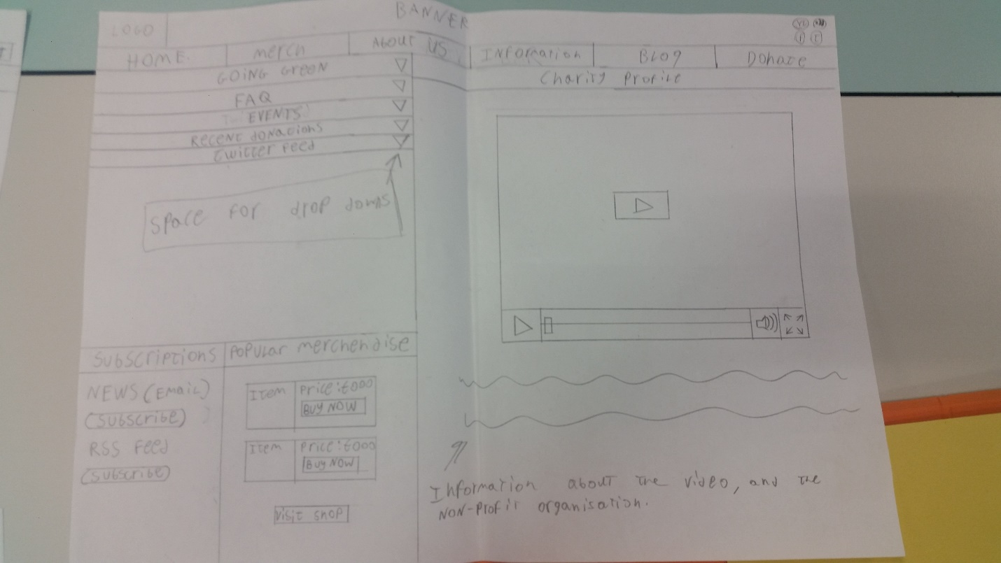

Above is the on paper design of design 2. This was a plan on making the website have a golden ratio. The content on most of the design are the same, I just experimented on the layout.

### Mood board/SEO

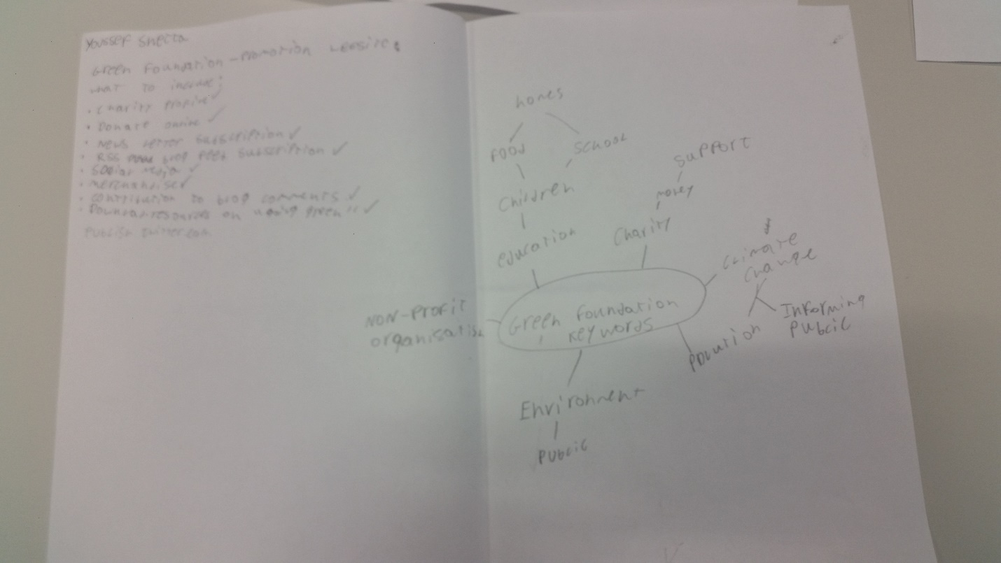

These are the notes and mind maps on what keywords are related to the website. This can be used to help with the search engine optimisation.

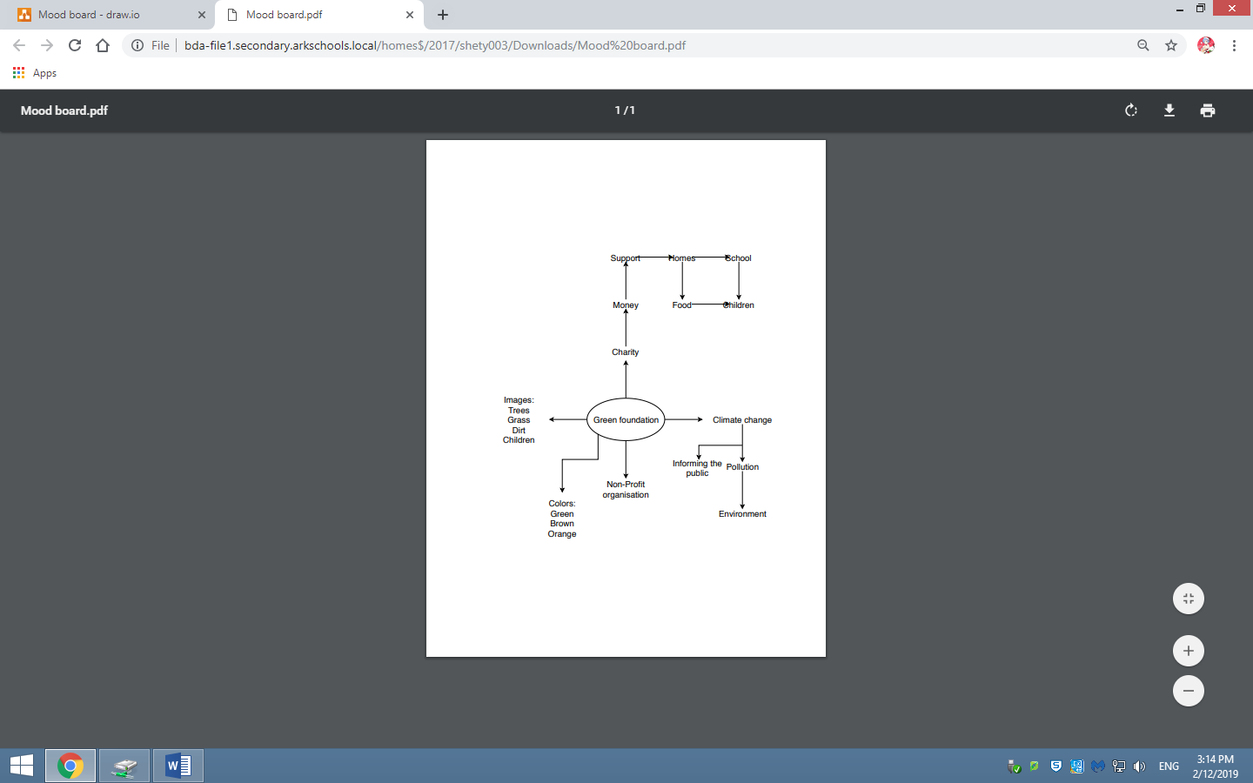This mood board is a copy of the paper mood board but with some changes like the images and the colours.

Green is for Nature and to calm people down. Although it might signify money it’s not what is aimed for here.

Orange is to invite people in as it’s known as friendly.

Pictures of employees helping people.

Community problems that the Green Foundation may be able to help with.

## P2/M2 Alternative Design ideas and prototyping

### Wireframe Design 1

This is from PDF”Unit 15 Templates without golden ratio”.

With this template I wanted to explore what the website would look like without the golden ratio, this let me explore my creativity with the principles of website design.

In my opinion the boxes fell out of place on the website because they are all different sizes and the white spacing between each box is not equal.

What website design principles I used in this design and why:

* White spacing- the reason to why I am using the white spacing is because it spaces the boxes from each other, making it easier to identify each box instead of them all being squished together.
* Accessibility- The website has multiple ways for people to access information for example if they are deaf they can access the same information from the video on the information page but if they are blind someone can put on the video for them and they can just listen to the information. What I can do is implement a language button that lets people pick what language to read in so that it is more accessible from other cultures.
* Alignment- the alignment of the popular merchandise box is done like that because people can see that the picture is the picture of the item and the text is the title telling them what it is and what price it is, the buy now button is also aligned that manner so people can identify that the buy now button is for that item.
* Simplicity- The website is simple in its colour scheme and design, all the information is presented in front of the user and if they want more information its one click away in the navigation bar at the top. The colours used are for giving the feeling of nature, peace and have an inviting feel because of the brown-orange for the background.

### Wireframe Design 2

For a clearer look at the design and annotations look for the pdf with the name of “Unit 15 template with golden ratio”

For this design I wanted to follow the principle of the golden ratio which promised the idea of it being visually appealing. This works with my website.

In comparison to design 1, this design is way more visually appealing because everything is so compact and there isn’t much space left untouched. This can attract people in because of the golden ratio or scare them off because of how much information is on the screen because of the way it looks compressed.

Principles used and why:

* Site layout- The website is laid out in that way because I wanted to use the golden ratio to help me make the website more visually aesthetic which helps the website gain more clicks and views which in turn might help use gain more donations.
* Consistency- I kept some of the principles of the last design because there was no reason to remove them, it would save me more time to experiment with the layout.

### Wireframe Design 3

This can be seen more clearly in a pdf file called “Unit 15 template 3”

New additions and why:

-Footer: I added the footer because every website has one to claim their copyrights to the website so that if someone were to copy it they have the law to try and take it down. It is also a place people go to look for the contact us page and for analytics on the organisation as well as information about their shareholders, it’s a place for navigation for those near the bottom.

-Navigation bar update- on the navigation bar there is a box with an arrow in it pointing up, I added this because it lets the visitor customise the webpage, this eliminates the worry of the website being too compact and scaring people away.

-Languages- I put the accessibility principle into action by adding a feature where the visitor can change the language that the website is displayed in, this lets me have a wider audience, this helps with the objective of getting people to donate more, the more people come visit the more of a chance that more people donate because there are a lot of people looking at the website.

What I removed and why:

-Information: the information tab was too vague, and I already had another tab for that, what I was going to put in for information I can put in the about us page where information about the organisation will be, this could be the aims and objects we are planning to achieve.

## Site map

This site map below is to show what is on the website, how many layers there are on the website.

## Obtaining and using feedback from others

When the website designs are complete it is important to gather feedback from possible users and the client to see if the designs meet the requirements and could be refined in any way to make them better because there might have been constraints that you were to stress about that you forgot to add something like the RSS feed. Also it’s important to see the problems before the launch so that you are able to identify them and find an alternative solution. In my case I will be using google forms to gain information by creating surveys to identify problems with the website and hopefully I will be able to find solutions to them.

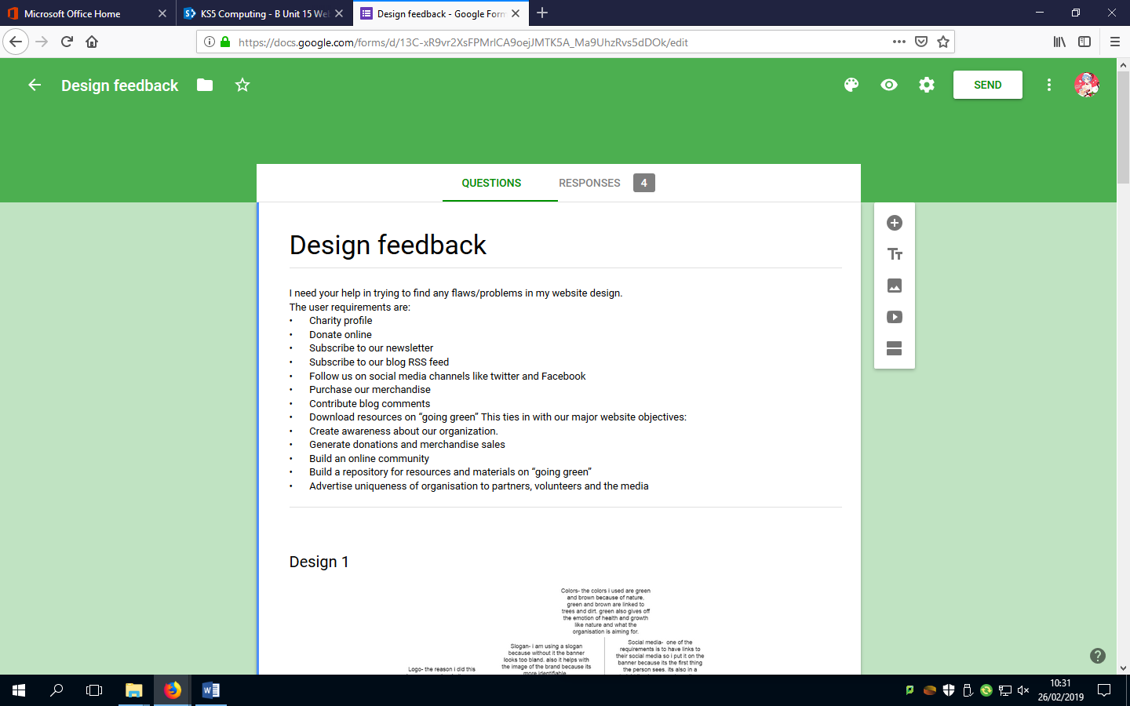

This is a survey that I sent out to people to get feedback on the designs I have made to potential visitors. This way I can get people to tell me what I should improve on and if they see a flaw or an issue they also have an option to tell me what that is.

## P3 Reviews

I used Google forms to create a survey for those who I think would be potential visitors to the website, I gave them the user requirements and I asked a few questions about what I could improve based on those requirements. And the reviews I got were helpful, although I think I got a bad review that was worded in a way that was hostile but the information they passed could be used to try and improve the website.

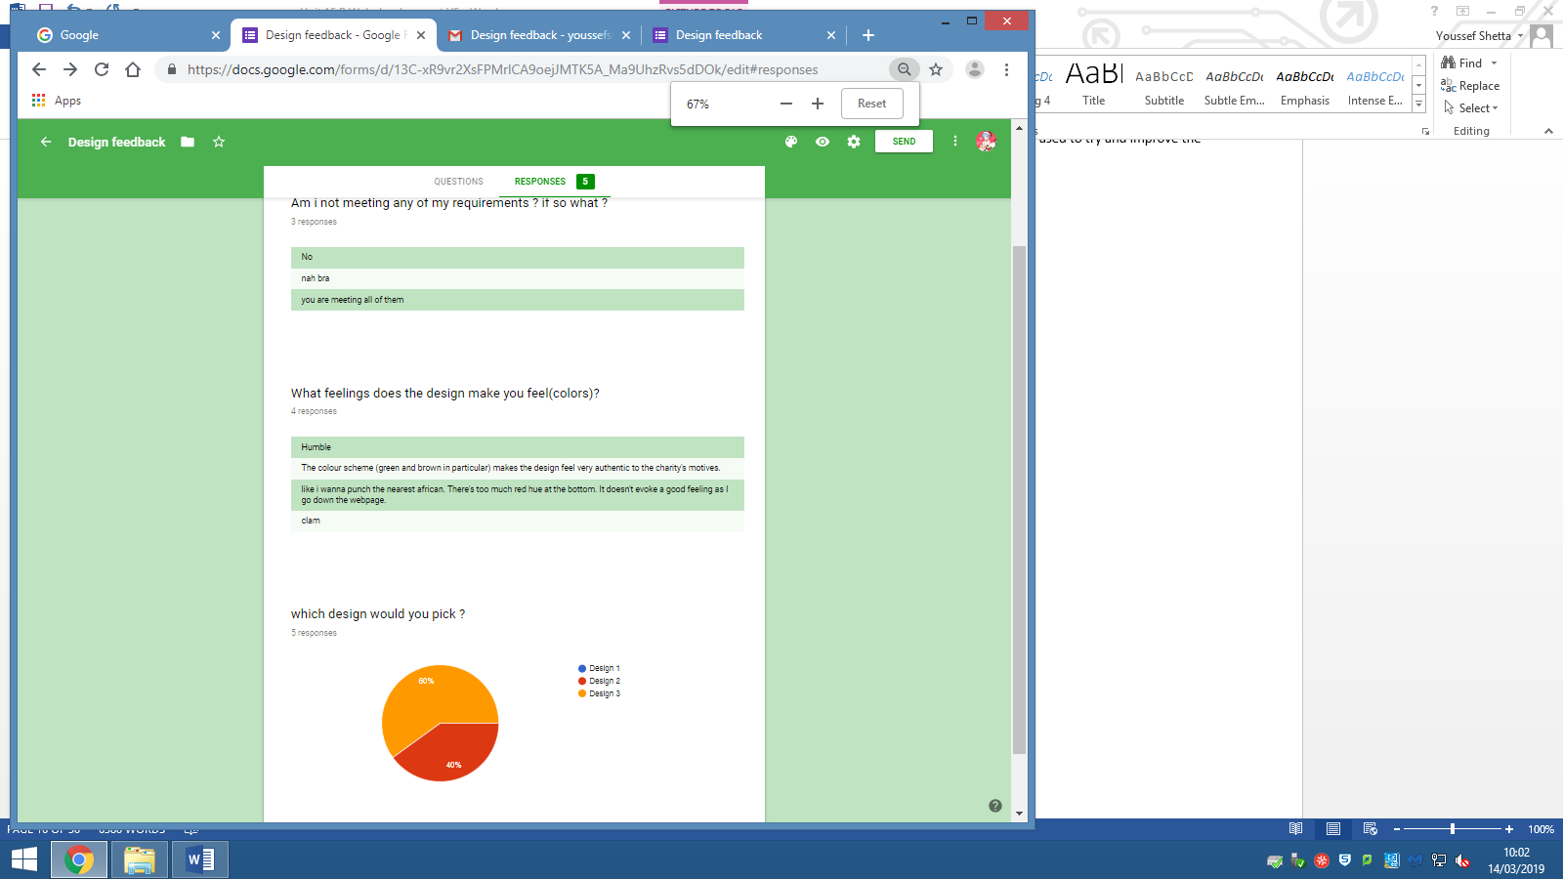

## Client side design

In this section I will be designing what the client side processing designs will be, so flowcharts for the client side applets and downloads. Then I will produce a psudocode based on that flowchart. This is done to help me create the website when it comes to coding.

### Flowchart for video client side design

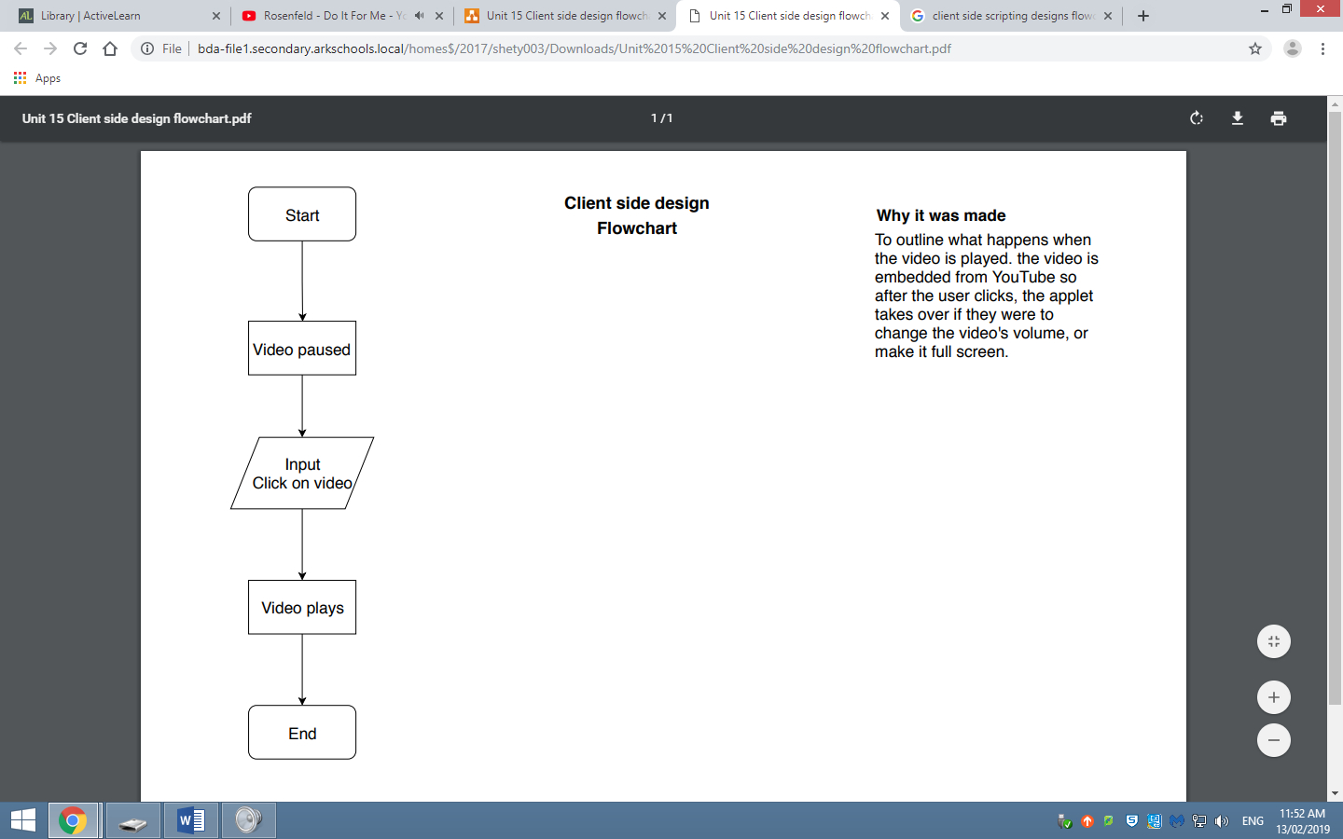

### Psudocode for the flowchart above

Begin

Video = video paused //initialises the video to be in pause state

Video = input (click) //lets the visitor have the option to start the video

Video = video play //when the input is done the video goes to the state of playing

End

### Flowchart for download client side design

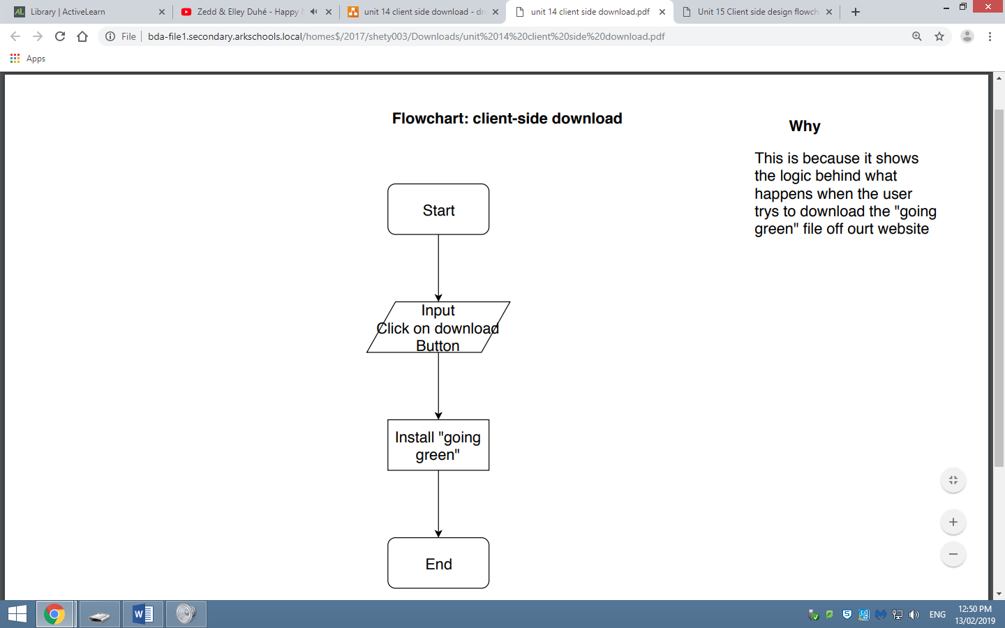

### Psudocode for the flowchart above

Start

Download = Input (click)”Download Going Green”//input from the user to install the file

Install = Download going green// installs the file from online storage.

End

### Flowchart for navigation bar

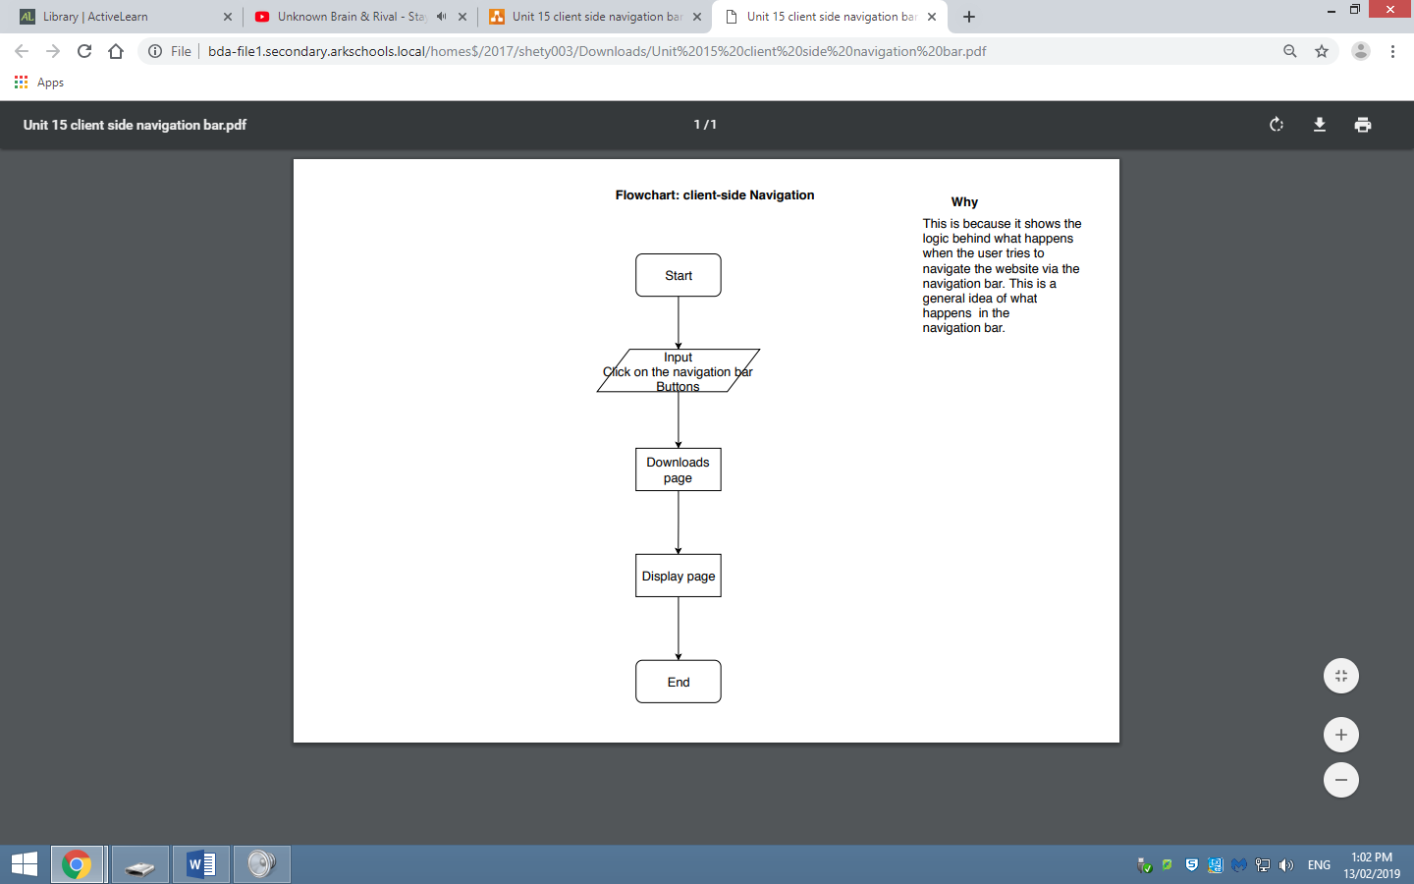

### Psudocode For navigation bar

Start

Navigation = Input (click) //user inputting a command to the browser to navigate to the next page

Download page //downloads the page so that when it loads the page for display all the recourses

Are there

Display page //Displays the page after download is done by using the resources

End

## Ready-made and/or original assets

The assets that I will include graphics and videos. There will be embedded within the web pages to provide additional interactivity, information or context.

### Ready-made assets

It is important that when using ready-made assists, they are copy right free or you have bought them, this is because if they are copyrighted and you use them without permission it might cost you more money to pay off the legal fees then if you were to buy them, it might even take you prison for braking the copyright law. So taking that risk is not worth it. As long as you have permission for the assets you use its ok. For my website I am using ready-made assets from a website called “Hatchful” which is a website that let you create a logo and slogans, for free and it’s also copyright free.

### Original assets

Original assets are not also risk free, if there is a person in your photograph that you took and you want to use the photo for something, you have to get that person to give you permission to use their face. This is done with a slip of some sort where thy have to give in their signature. The reason this is done is because if they were to take you to court and you don’t have solid proof of them giving you permission it might cost you a lot of money. The only thing that I’m using as original assets is the content (as of right now), and the download “going green file”.

## Testing plan

|  |  |  |  |  |  |
| --- | --- | --- | --- | --- | --- |
| Test number | | Purpose of test | Page | Test data | Expected result |
| 1 | | Testing home button on the navigation bar. | Home.html | Click on the Home button on the navigation bar | Loads the home page |
| 2 | | Testing Merchandise button on the navigation bar. | Merch.html | Click on the merchandise button on the navigation bar | Loads the merchandise page |
| 3 | | Testing the about us button on the navigation bar. | Aboutus.html | Click on the about us button on the navigation bar | Loads the about us page |
| 4 | | Testing the blog button on the navigation bar. | blog.html | Click on the blog button on the navigation bar | Loads the blog page |
| 5 | | Testing the donate button on the navigation bar | Paypal.com | Click on the donate button on the navigation bar | Loads the PayPal donation service |
| 6 | | Testing the drop down navigation bar | Any page | Click on the arrow on the navigation bar | Drops down or sends the navigation bar up out of sight |
| 7 | | Testing the drop downs for going green | Home.html | Click on the arrow next to the going green on the left of the home page | Drops down a download button |
| 8 | | Testing the download button for going green | Home.html | Click on the download button after drop down | Downloads the document |
| 9 | | Testing the FAQ Drop down | Home.html | Click on the drop down for FAQ | Panel drops down with frequently asked questions |
| 10 | | Testing the Events drop down | Home.html | Click on the drop down for Events | Shows current events and scheduled events |
| 11 | | Testing the drop down for the recent donations | Home.html | Click on the recent donations drop down | Shows the recent person for donations |
| 12 | | Testing the twitter feed drop down | Home.html | Click on the drop down for the twitter feed | Shows an updated twitter poste |
| 13 | | Testing the subscribe now button for the news letter | Home.html | Click on the subscribe now button | Sends emails to those who click it |
| 14 | | Testing the subscribe now for the RSS feed | Home.html | Click on the subscribe now button | Sends the visitor to the RSS feed |
| 15 | | Testing the buy now button for the popular merchandise | Home.html | Click on the buy now button | Sends the user to the check out |
| 16 | | Testing the visit now button under the buy now button | Home.html | Click on the visit button | Sends the visitor to the merchandise page |
| 17 | Testing if it works on internet explorer. | | Home.html | Opening Home.html using internet explorer | Everything opens normally |
| 18 | Testing if it works on google chrome | | Home.html | Opening Home.html using google chrome | Everything opens normally |
| 19 | Testing if it works on opera | | Home.html | Opening Home.html using opera | Everything opens normally |
| 20 | Testing if it works on the browser Firefox | | Home.html | Opening Home.html using Firefox | Everything opens normally |

## Legal and ethical considerations

There are legal and ethical considerations involved when designing and developing website. I will be talking about them in more detail below.

### Copyright, designs and patents act (1988)

Copyright is the law that protects the intellectual property of writers, musicians and other artists. People who illegally copy music, films, books or computer games are breaking this law. Various methods can be used to help protect intellectual property, such as encryption which stops people who do not have permission from seeing the data, meaning that they would need to buy or ask for the key to see the data which supports the artists as they gain money from it.

### Data protection act (1998)

This legislation defines the requirements for the organizations which legitimately store personal information about living individuals, for example banks, schools, hospitals, etc. they would have to makes sure that the data of those living individuals are used fairly and lawfully meaning that it needs to be verified by the law and that if anything happens to it (negatively) it will be fixed with no cost to the individual. It should also be used for limited, specifically stated purposes, meaning that the information should be held for only a little bit of time and that they also must state the purpose of using the data, like what the organization is going to do with it, for example a bank would say that the card would expire on a certain date which is the limited time that bank can hold the data for and that they need to state that they are storing money for people who give them their information. Another way the data is needed to be used is that of an adequate, relevant and not excessive way, meaning that the organization need to make sure that they’re doing what the individual is signed up to do and not use it for any other purposes. They also need to make sure that the information is accurate as inaccurate information can lead to a very complicated result. The organization also needs to make sure that the data is safe and secure so that no one can steal their identity or use their personal information for deeds that are not morally acceptable. Lastly, they need to abide with the rule of the data not being transferred outside of the European economic area without adequate protection, meaning that they cannot send any information past Europe.

# B2- Common tools and techniques used to produce websites

There are different tools and techniques for developing a website, these tools are used in order to meet the client’s requirements easier and more efficiently.

## HTML

HTML stands for hypertext mark-up language, this is the most common used mark-up language to the point where the others are not used. It forms the basis of all worldwide web pages. HTML uses a system of tags which contain the instructions. Almost all instructions come in a pair of open and closed tags enclosing the content to be affected.

## HTML5

HTML5 is the current hypertext mark-up language standard used for structuring and presenting content on the website. Website developers should always work to the current standard so when developing the web pages, they use the right standard. Tag for changing the font are no longer required in HTML5 instead cascading style sheets should be used. I will be using css to help with all the visuals on the website, while I use the HTML for creating the pages.

## Tables

Tables should not be used to structure website because it causes accessibility and browser rendering issues. Instead tables should be used only to present a table on a webpage for example the opening the times for a shop. The tables I will be using would be for the events schedules

## Forms

Forms are used in website development to collect user inputs, all screenshots I have used below are me testing each form. Below are examples of the different types of forms.

### Text field

This defines a one-line input field for text input.

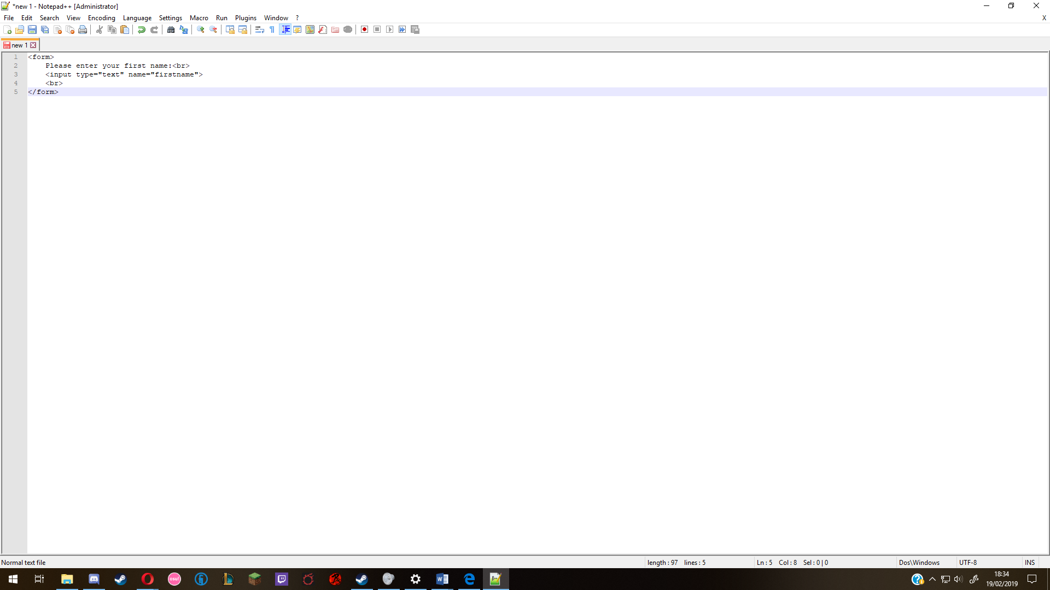

### Text area

Allows you to have more user inputs.

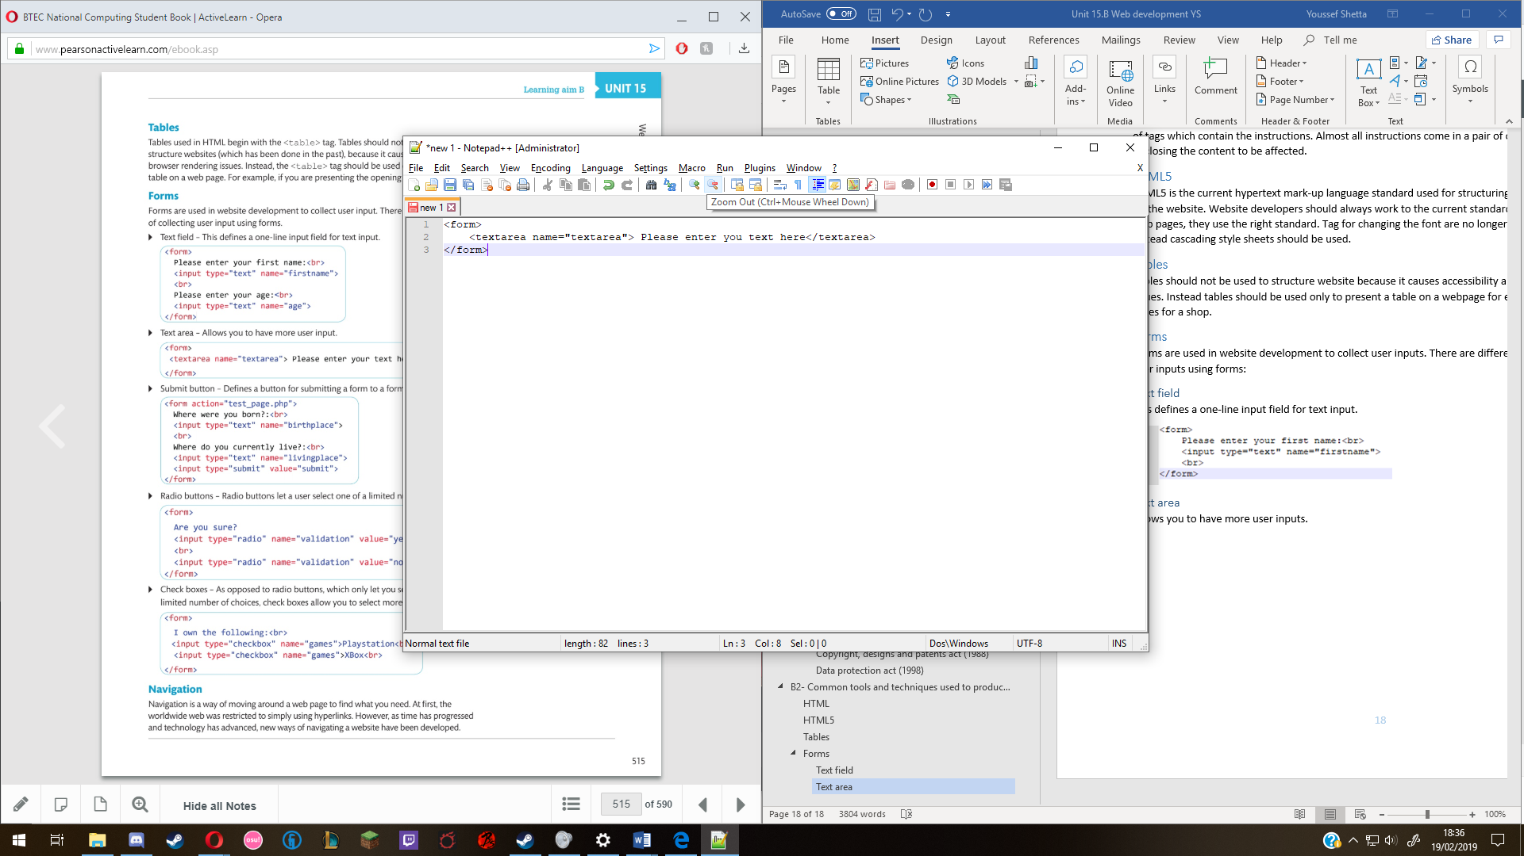

### Submit button

Defines a button for submitting a form to a form handler.

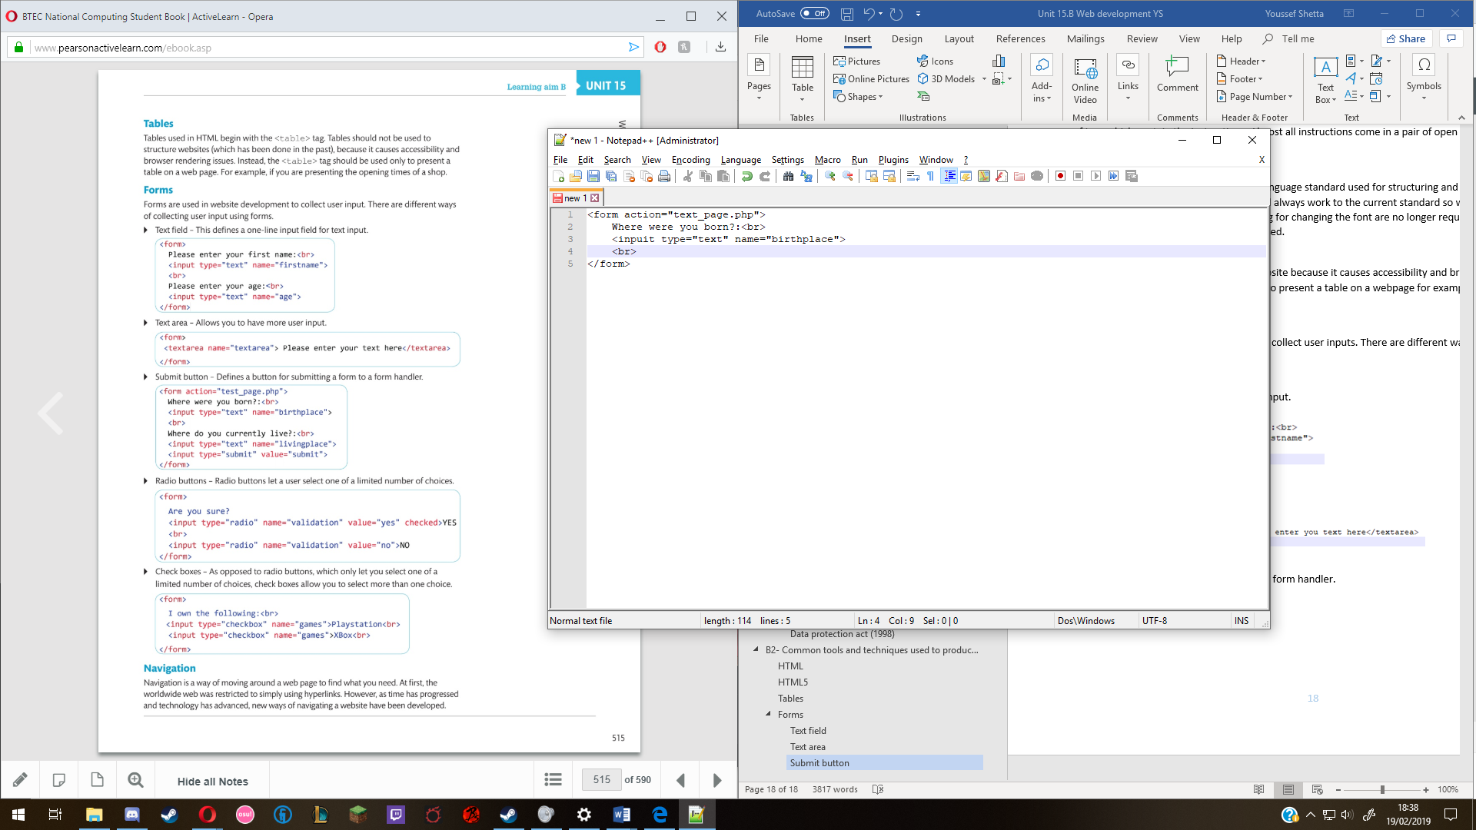

### Radio buttons

Radio buttons let a user select of a limited number of choices.

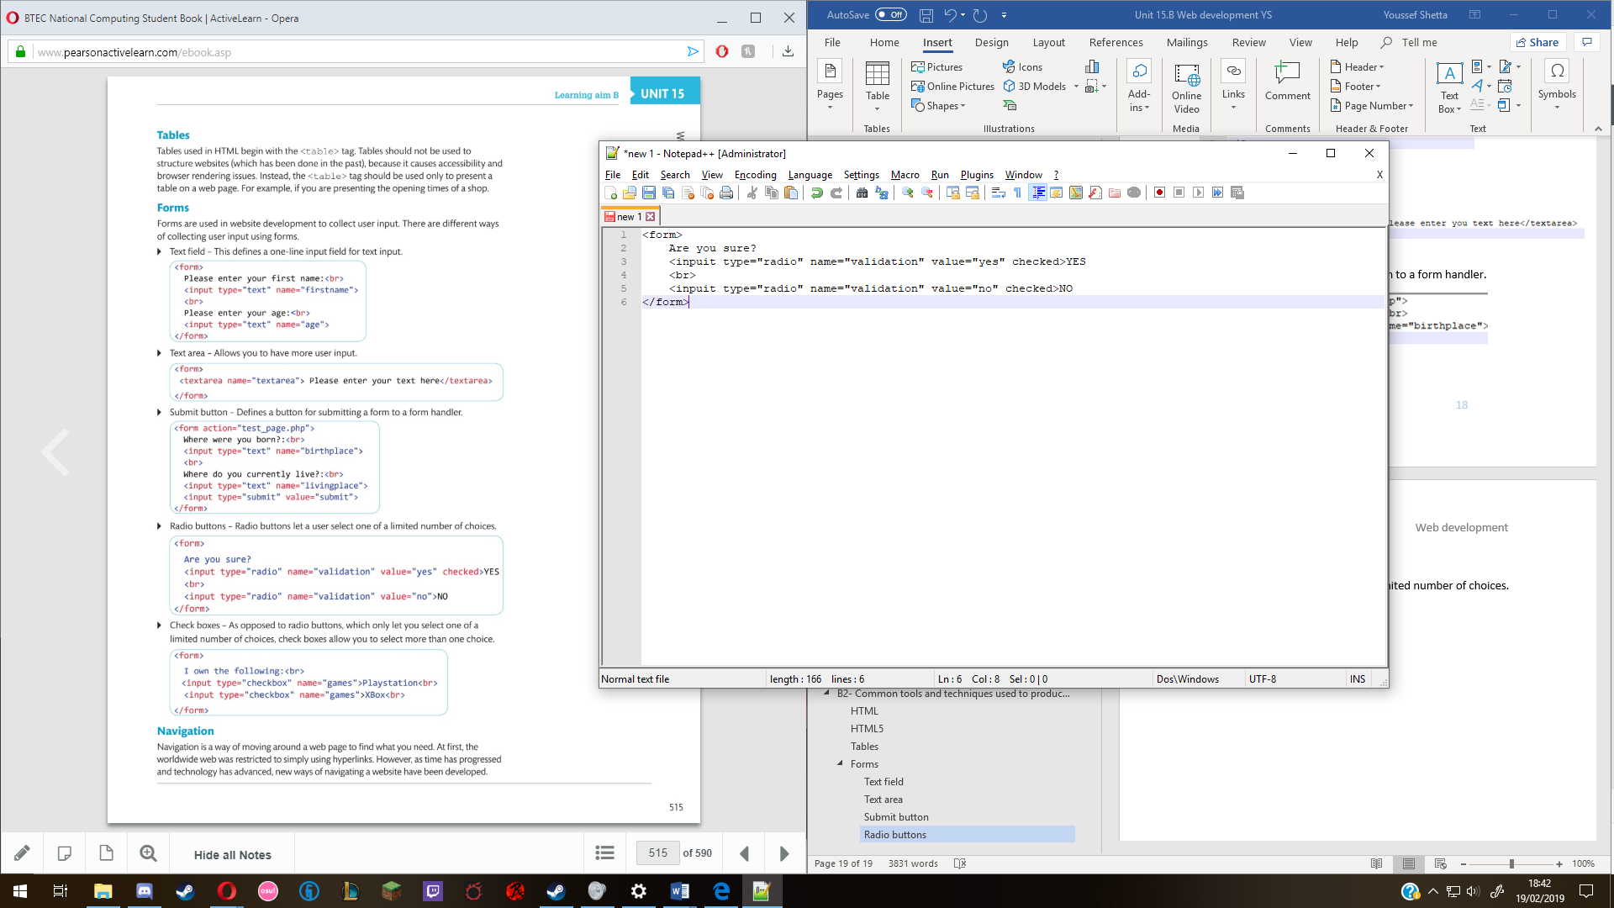

### Check boxes

As opposed to radio buttons, which only let you select one of a limited number of choices, check boxes allows you to select more than one choice.

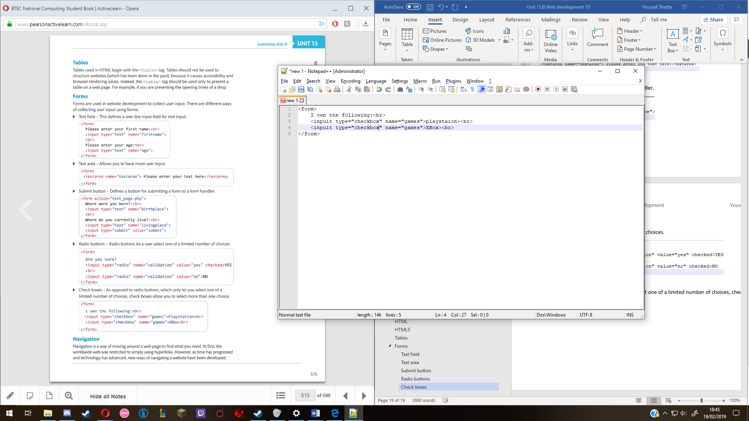

## Navigation

Navigation is a way of moving around on a webpage to find information that you need. This is done in many ways, this is listed below.

### Menus

Menus appear anywhere within a webpage, but most website developers tend to place them towards the top of a webpage. These are more aesthetically pleasing than the traditional hyperlinks. In my design the navigation bar is a menu.

### Hyperlinks

These are links that when clicked on take you to particular parts of the website or they will take you to another websites, these can be in forms of text, images or buttons. The only hyperlinks in the website will be the texts in footer.

### Anchors

These are used to redirect a visitor to a certain part of a webpage. For example, if you are reading a long document online at the beginning of the webpage there will be links to the beginning of each section within the document. By clicking on one of these sections it will link redirect you to the precise point in the webpage. My website does not need an anchor as it only has a few layers and not that much information to scroll through. Below is an example of a website using anchors.

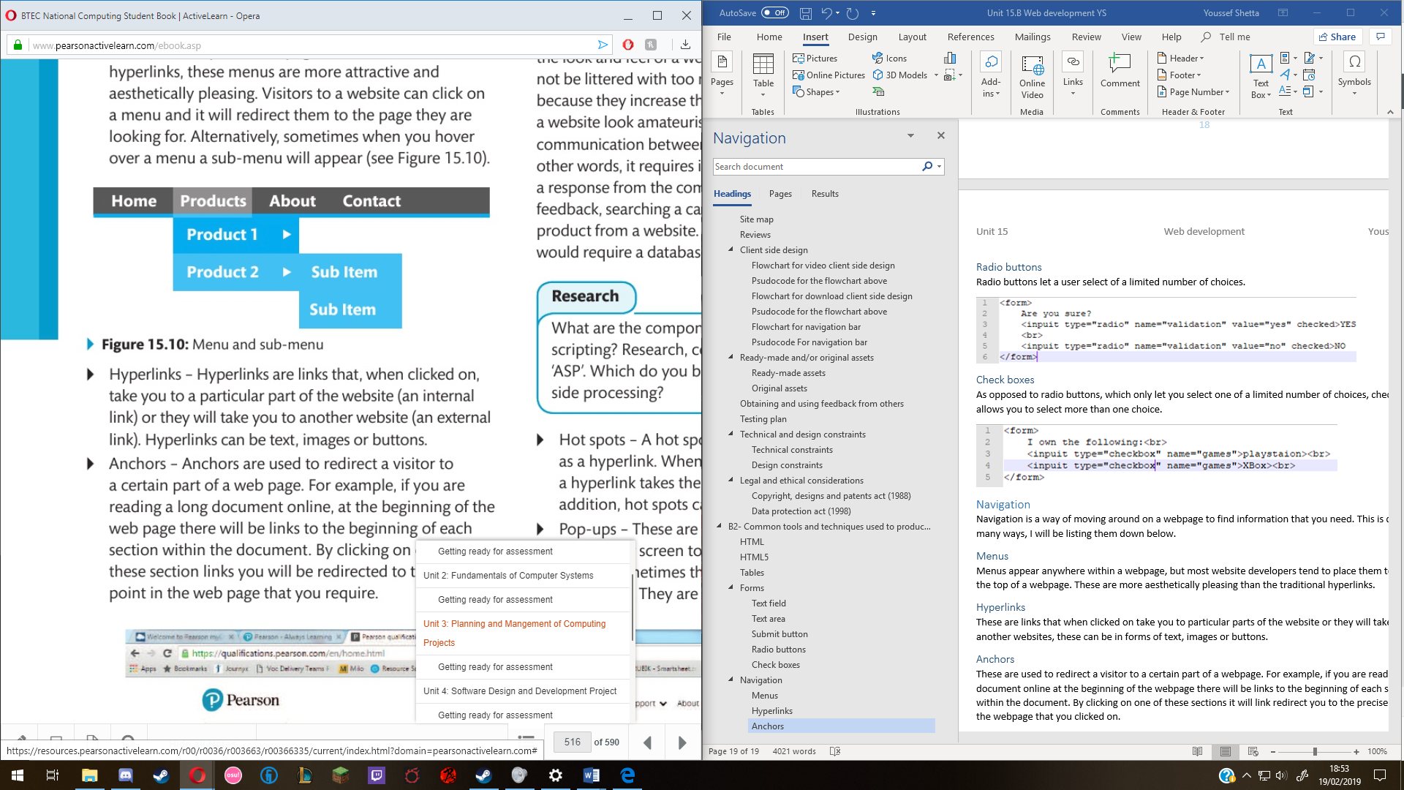

## Interactive components

Interactivity involves two-way communication between the user and the computer. In other words, it requires input from the user which provokes a response from the computer. This could include giving feedback searching a catalogue of products or purchasing a product from a website.

### Hot spots

A hotspot is an area of an image that acts as a hyperlink. When a person clicks on a hot spot, a hyperlink takes the user to another webpage. This will be used to link the logo at the top of the webpage to the home page.

### Pop-ups

These are small internet windows that pop up on your screen to get the user’s attention. These are considered annoying or dangerous because they are often used by advertisers. An example of when a pop-up shows is when you first visit a website, a pop-up will appear to tell you that cookies for that website will be downloaded to your pc, and you have to accept them in order to continue using the website. I don’t want to use pop ups as it might detour people off my website.

### Buttons

These look like command buttons in that when you press them, they will depress like a conventional button, buttons have different purposes one of which can take you to another web page. I will be using buttons for my navigation bar to make it look more appealing.

### Rollover images

A rollover image is a secondary image that is loaded into your webpage to display when a user on your website rolls their mouse over a certain image within your website. There is no need for my website to have rollover images so I will not use it.

## Colour schemes, styles and templates

Modern web designs within HTML5 use templates with built-in colour schemes and styles. There are templates which are free to download and some that you have to pay for. These templates are built using techniques called CSS which is has already been mentioned before. But will be discussed in more detail further in the report. What makes an appropriate or pleasing template is subjective, it is a matter of opinion. Quite often the colour scheme and styles used by your website will determine its theme. Therefore, you must choose appropriate colours based on your website. The theme I’m going for is green/nature so there will be a lot of green and brown.

## CSS (Cascading style sheets)

CSS is used to ensure standardised formatting across a website. CSS allows you to create a standard layout and style that can be applied across all the web pages within a website. This is used to make sure that code is not repeated across the HTML file. This makes altering and maintaining the design of the website much easier.

## The World Wide Web consortium

The W3C is a body which promotes the standardisation of web design, especially of HTML. It aims to ensure universal accessibility of the web. For example, they want all websites to be displayed on a variety of browsers and resolution so that they are usable by people with special needs.

## Accessibility features

Below I have listed all the features that allow people to access the website more easily.

### Alt tags

An alt tag is a text alternative for an image or object on your webpage. This is used for website readers to be able to describe the picture for those who are blind. So, alt tags need to be meaningful it has to say what is shown in the image and in what context it is in.

### Zoom features

Web browsers have a feature which allows the user to zoom in or out, making the content on the screen larger or smaller depending on their preference. This is useful for those who have poor vision.

### Text-to-speech

For visually impaired users, text-to-speech is very useful. It is a type of speech synthesis application that is used to create spoken sound version of the text in a webpage.

## Platform compatibility

When developing website, it is important that they are tested across a range of different platforms, these are able to be put into three categories:

* Web browsers
* Operating systems
* Mobile devices

These have to be tested for if it’s in the client’s requirements to have the website be displayed on every device they can possibly get on, this is obviously very expensive, so it’s the web developer’s job to see the budget and prioritise the category that will benefit that type of website.

## Embedding and compression of assists into suitable file types

Compression is a way of making a file smaller so that is uses less disk space, by doing this the website will load faster due to the small amount of data that needs to be downloaded, this makes it more user-friendly as the user does not have to wait a long time to access the website.

### Image files

There are two image file types available: bitmap and vector

Bitmap file types include .gif and .jpeg. A .gif has a maximum palette of 256 colours and should therefore be used when the quality of the colour image is not that high and for images that do not contain many shades of colour. .jpegs have a larger colour palette and is therefore better for high-quality colour images that include a lot of shading.

### Digital sound files

There are several types of sound files available, each with its own method of sampling and compression. A .wav files has a high sample rate which means that the sound quality is closest to that produced by an actual instrument, but this has a relatively large file size. An .mp3 file tends to have a lower sample rate and therefore produces a smaller file size. However, there is a loss of quality with.mp3 files compared to .wav files. The higher the compression rate the smaller the file size bit this is at the cost of some fidelity.

### Digital video and animation files

Traditionally for users to be able to view videos or animations embedded within a web page, they used to have to click on them and download them. Due to the size of the files this would take a long time and take most of the bandwidth with it, files like those also tend to take up a lot of space on the server. However, with the advent of HTML5 more videos are being embedded into web pages which can now show animations and videos without the need of a plug-in.

### Exporting digital assets

Once your digital assets have been created and developed using appropriate file types these files can then be exported for the website to use. When exporting your files, you should develop a folder directory which will store all your assets including images, sounds, videos and animations as well as CSS files. This will mean that your files will be sorted appropriately and you will be able to refer to them when you code your website solution.

# B.D2 Evaluate the design and optimised website against client requirements

I will be referring to my designs of my wireframe throughout this evaluation, as well as the mood board and site map. The first design on paper was made to outline what content is going to be on the website. One of the client’s requirements wanted the website to be able to build a community. To achieve this, I set up a section on the home page for recent donations and for social media like Twitter. This would hopefully give people a reason to donate, as their name will be shown for the public eye to see. This can help to create a community, as people can donate multiple times, which in turn shows their name more often so people can get familiar with each other. For building a community, I embedded a twitter feed and linked all the social media at the top by the heading. There is also a blog that was requested to be implemented, which will hopefully help with developing a community as it will be a way for people to talk to each other.

For my second design, I copied the content that was on the first design, which is important to get correct as they are the client’s requirements. Therefore, I need to figure out how the page is going to be laid out, by using the design principles that were explored in Section A. The first design had boxes that had the content inside it. The reason for this is because the information would not clutter the page. The goal was to make the page look aesthetically pleasing to the visitor, and not something that they would feel contempt with. In design two, I was testing out how the golden ratio would look with the content from design one. The problem that I ran into was that in the design, I tried to fit as much information as I could on the first page. This would work if the website had scrolling, but the home page looked too cramped and that might drive away visitors, which goes against the client’s requirements of generating donations, merchandise sales and creating awareness about the organisation.

To fix this problem of having a cluttered homepage, I created a third design which has the addition of a drop down to both the navigation bar and all the other tabs. The goal of adding the drops downs was to make it so the user can pick what information they want to see; this would make it better as the information they seek can be on the first page without driving them away. To help me decide on what design to pick, I posted a survey that I sent out to potential visitors. The results were 60% for design three and 40% for design two and design one was not picked at all. This helped me pick design 3 as the majority liked the look of that design. I also agree with the majority because the practical usage of the downs help meet the client’s requirements as its not driving visitors away.

## Website Optimisation

For the optimisation of the website I will try to put these into practice:

* Reducing HTTP requests by using CSS. This makes it so that there isn’t much load time.
* Compress the web files like the “going green” file, it will be compressed to a rar file to help those who want to download it to download it faster.
* I will be using Dreamweaver over Wix as it’s a WYSIWYG website development tool which can create messy code which then can slow down the website. While in Dreamweaver I can control everything.
* For images I will consider the size of the image to see if it would take a while to load.
* I will only have one CSS file that is used for every page of the website as it makes it more efficient as I would have to repeat the CSS for the header if I don’t, and that’s inefficient.

# Bibliography

Pearson BTEC National computing student book was used in this report. Pages 505-519.